Adaptive Responses
Erin Stansbury-Wiles
Walden University
NURS 6501 – Advanced Pathophysiology

Adaptive Responses
The human body is composed of two immune responses: innate and adaptive (Huether & McCance, 2012). The two immune responses work together to eliminate pathogens in the human body. Adaptive immune responses are responsible for targeting and destroying specific pathogens (Huether & McCance, 2012). The purpose of this paper is to identify the pathophysiology of the disorders described in the scenarios and describe their adaptive responses to the pathologic alterations.
Scenario 1: Tonsillitis
The child presents with a painful sore throat, swollen tonsils with 4+ edema, swollen anterior cervical lymph nodes, poor appetite, and a fever >101° Fahrenheit. Without further information, like a throat culture or the appearance of the throat, this would indicate tonsillitis.
The most common cause of tonsillitis is group A beta-hemolytic Streptococcus pyogenes (GABHS) that enter through the nose and mouth (Yildizoglu, 2015). GABHS adheres to the tonsil epithelium and can be controlled by macrophages in the cells. If the macrophages are not able to control the GABHS then they release cytokines and the inflammation process starts to occur. Inflammatory changes in the tonsils include vasodilation and increased capillary permeability which present clinically as tonsillar exudate, fever, and a sore throat (McPhee & Hammer, 2010). Tender and enlarged lymph nodes occur because these nodes filter or trap foreign particles that enter the body (Yildizoglu, 2015).
Scenario 2: Irritant Contact Dermatitis
Irritant Contact Dermatitis (ICD) is a non-specific response of the skin to direct contact of an irritant (McPhee & Hammer, 2010). Exposure to chemicals causes damage to the epidermis and triggers a release of interleukin 1, 6, 8 as well as a tumor necrosis factor (Simon, Aeberhard, Erdemoglu, & Simon, 2014). This release results in the inflammation process which clinically presents as irritated, cracked, and reddened dermis (Huether & McCance, 2012).
Scenario 3: Stress Response
Case three depicts someone experiencing a stress response which results in an increased secretion of glucocorticoids (cortisol and anti-inflammatory cytokines) from the hypothalamic pituitary adrenal axis (HPA) (Huether & McCance, 2012). The HPA works as an adaptive system to maintain equilibrium in a changing environment (Wolkow, Ferguson, Aisbett, & Main, 2015). Glucocorticoids control many functions of the central nervous system including: arousal, cognition, sleep, mood, and cardiovascular tone (Huether & McCance, 2012). Therefore an increase in glucocorticoids during the stress response results in adaptive changes so that body can respond to the environmental change. Adaptive responses noted in this scenario included changes in her sleep, her appetite, and a “racing” heart.
Summary
Humans would not be able to survive without innate and adaptive immune responses. These initial responses start without human cognizance. The purpose of this paper was to identify the pathophysiology of the disorders in the presented scenarios and describe their adaptive responses to the pathophysiological alterations. This was done by examining the clinical presentation of each scenario and researching the pathophysiological changes that occur. In addition, this paper described the adaptive responses that followed the pathophysiological changes. Mid-level providers must be aware of human adaptive responses because they are signs and symptoms of changes or underlying issues within the body.

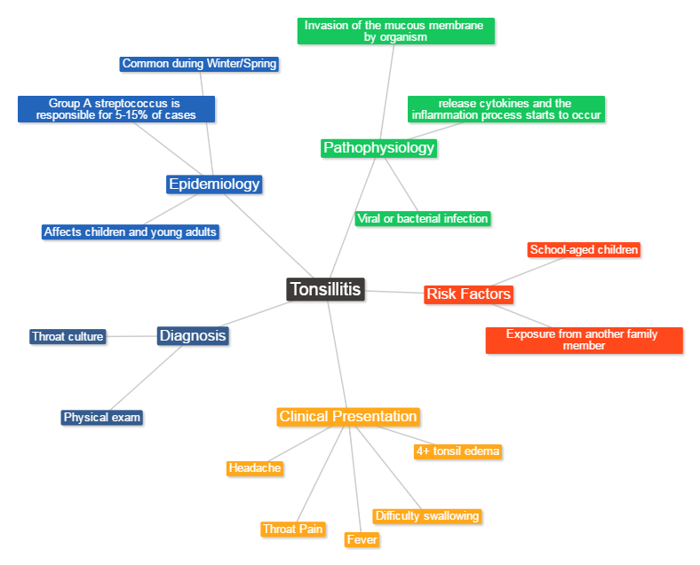

Reference
Huether, S. E., & McCance, K. L. (2012). Understanding pathophysiology (Laureate customed.).
St. Louis, MO: Mosby.
McPhee, S. and Hammer, G. (2010). Pathophysiology of disease: An introduction to clinical
medicine (Laureate Education, Inc., custom ed.). New York, NY: McGraw-Hill Medical.
Simon, D., Aeberhard, C., Erdemoglu, Y., & Simon, H. (2014). Th17 cells and tissue remodeling
in atopic and contact dermatitis. Allergy, 69(1), 125-131. doi:10.1111/all.12351
Wolkow, A., Ferguson, S., Aisbett, B., & Main, L. (2015). Effects of work-related
sleep restriction on acute physiological and psychological stress responses and their
interactions: A review among emergency service personnel. International Journal of
Occupational Medicine & Environmental Health, 28(2), 183-208 26p. doi:10.13075/ijomeh.1896.00227
Yildizoglu, U., Polat, B., Gumral, R., Kilic, A., Tosun, F., & Gerek, M. (2015). Effect of
antibiotic use on bacterial flora of tonsil core in patients with recurrent tonsillitis.
European Archives of Oto-Rhino-Laryngology: Official Journal of The European
Federation of Oto-Rhino-Laryngological Societies (EUFOS): Affiliated With The
German Society for Oto-Rhino-Laryngology - Head and Neck Surgery, 272(6), 1525-
1528. doi:10.1007/s00405-014-3434-3

Walden University M.S. in Nursing
Formative Evaluation Criteria for Applications and Formal Papers

Categories and Criteria |  |  | Points
QUALITY OF WORK SUBMITTED - 35 Possible Points
1. The extent to which work meets the assigned criteria and work reflects graduate level critical and analytic thinking (0-30 Points)
Assignment exceeds expectations. All topics are addressed with a minimum of 75% containing exceptional breadth and depth about each of the assignment topics. | 25-30
Assignment meets expectations. All topics are addressed with a minimum of 50% containing good breadth and depth about each of the assignment topics. | 20-24
Assignment meets most of the expectations. One required topic is either not addressed or inadequately addressed. | 16-19
Assignment superficially meets some of the expectations. Two or more required topics are either not addressed or inadequately addressed. | 0-15
2. Purpose of the paper is clear (0-5 Points)
A clear and comprehensive purpose statement is provided which delineates all required criteria. | 5
Purpose of the assignment is stated, yet is brief and not descriptive. | 4
Purpose of the assignment is vague. | 1-3
No purpose statement was provided. | 0
ASSIMILATION AND SYNTHESIS OF IDEAS - 50 Possible Points
The extent to which the work reflects the student’s ability to-
1. Understand and interpret the assignment’s key concepts (0-10 Points)
Demonstrates the ability to critically appraise and intellectually explore key concepts. | 9-10
Demonstrates a clear understanding of key concepts. | 8
Shows some degree of understanding of key concepts. | 5-7
Shows a lack of understanding of key concepts, deviates from topics. | 0-4
2. Apply and integrate material in course resources (i.e. video, required readings, and textbook) and credible outside resources (0-20 Points)
Demonstrates and applies exceptional support of major points and integrates 2 or more credible outside sources, in addition to 3-4 course resources to support point of view. | 15-20
Integrates specific information from 1 credible outside resource and 3 to 4 course resources to support major points and point of view. | 10-14
Minimally includes and integrates specific information from 2-3 resources to support major points and point of view. | 3-9
Includes and integrates specific information from 0 to 1 resource to support major points and point of view. | 0-2
3. Synthesize (combines various components or different ideas into a new whole) material in course resources (i.e. video, required readings, and textbook) by comparing different points of view and highlighting similarities, differences, and connections. (0-20 Points)
Synthesizes and justifies (defends, explains, validates, confirms) information gleaned from sources to support major points presented. Applies meaning to the field of advanced nursing practice. | 18-20
Summarizes information gleaned from sources to support major points, but does not synthesize. | 16-17
Identifies but does not interpret or apply concepts, and/or strategies correctly; ideas unclear and/or underdeveloped. | 14-15
Rarely or does not interpret, apply, and synthesize concepts, and/or strategies. | 0-13

WRITTEN EXPRESSION AND FORMATTING - 15 Possible Points
1. Paragraph and Sentence Structure: Paragraphs make clear points that support well developed ideas, flow logically, and demonstrate continuity of ideas. Sentences are clearly structured and carefully focused--neither long and rambling nor short and lacking substance. (0-5 Points)
Paragraphs and sentences follow writing standards. | 5
Paragraphs and sentences follow writing standards 80% of the time. | 4
Paragraphs and sentences follow writing standards 70% of the time. | 3
Paragraphs and sentences follow writing standards < 70% of the time. | 0-2
2. English writing standards: Correct grammar, mechanics, and proper punctuation (0-5 Points)
Uses correct grammar, spelling, and punctuation with no errors. | 5
Contains a few (1-2) grammar, spelling, and punctuation errors. | 4
Contains several (3-4) grammar, spelling, and punctuation errors. | 3
Contains many (≥ 5) grammar, spelling, and punctuation errors that interfere with the reader’s understanding. | 0-2
3. The paper follows correct APA format for title page, headings, font, spacing, margins, indentations, page numbers, running head, parenthetical/in-text citations, and reference list (0-5 Points)
Uses correct APA format with no errors. | 5
Contains a few (1-2) APA format errors. | 4
Contains several (3-4) APA format errors. | 3
Contains many (≥ 5) APA format errors. | 0-2
Total Points for Assignment:

